Triangle–Circular Mixed Shapes
# Source: AI Source: Provided by: [Data Path: Persons Table -> ID Column: 1, Name_En Column: Motasem Essam] -> From: [ChatGPT] on [7/25/2026]
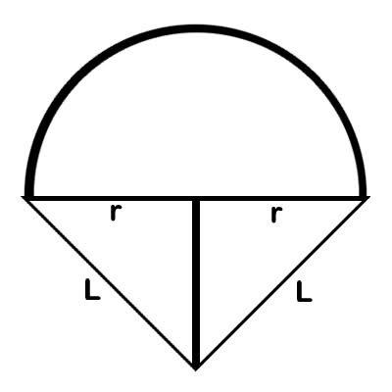
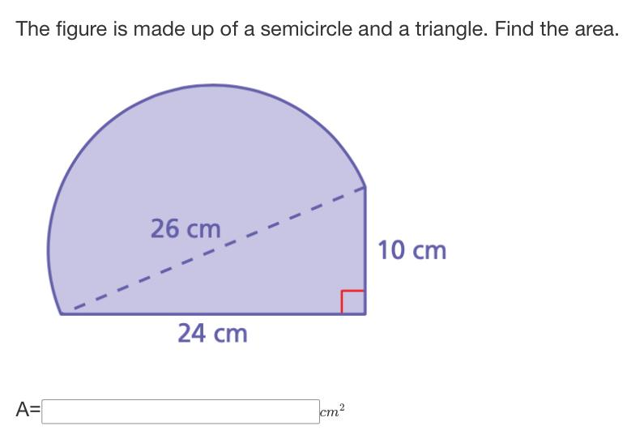
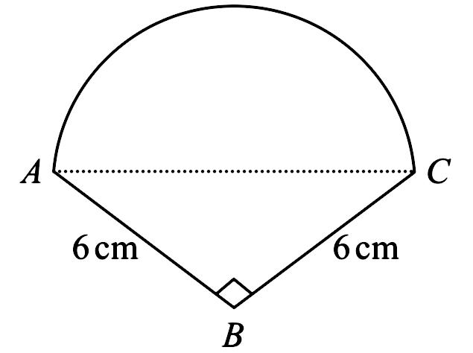
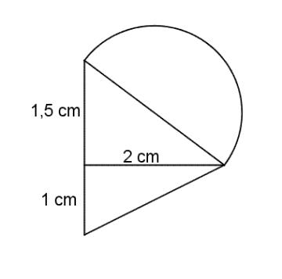
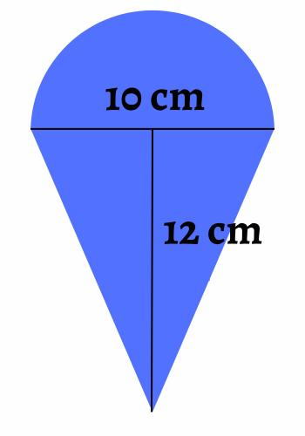

Definition
# Source: AI Source: Provided by: [Data Path: Persons Table -> ID Column: 1, Name_En Column: Motasem Essam] -> From: [ChatGPT] on [7/25/2026]
A Triangle–Circular Mixed Shape is an irregular composite shape formed by combining a triangular component with one or more circular elements or circular arcs.
In simple terms:
It is a shape that combines straight triangular boundaries with circular curved boundaries.
$$\boxed{\text{Triangle–Circular Mixed Shape}=\text{Triangle}+\text{Circular Element}}$$

Characteristics
# Source: AI Source: Provided by: [Data Path: Persons Table -> ID Column: 1, Name_En Column: Motasem Essam] -> From: [ChatGPT] on [7/25/2026]
A Triangle–Circular Mixed Shape typically:
- Contains a triangular component.
- Contains at least one circle, semicircle, circular arc, or circular segment.
- Has both straight and curved boundaries.
- Has a mixed boundary.
- Is generally classified as an irregular mixed shape.
- Can often be decomposed into simpler geometric components.
- May be formed by adding or subtracting circular portions from a triangle.

Common Types

1. Triangle + Semicircle
# Source: AI Source: Provided by: [Data Path: Persons Table -> ID Column: 1, Name_En Column: Motasem Essam] -> From: [ChatGPT] on [7/25/2026]
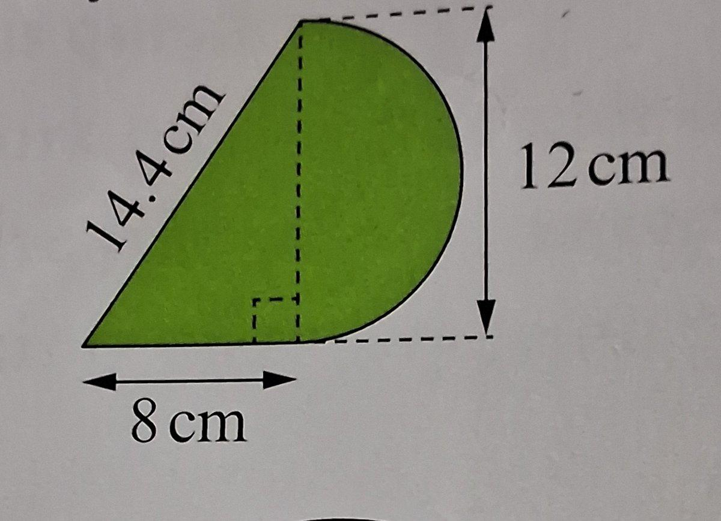


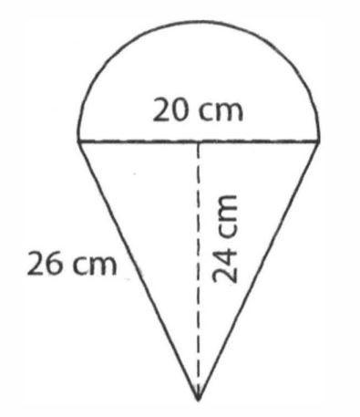
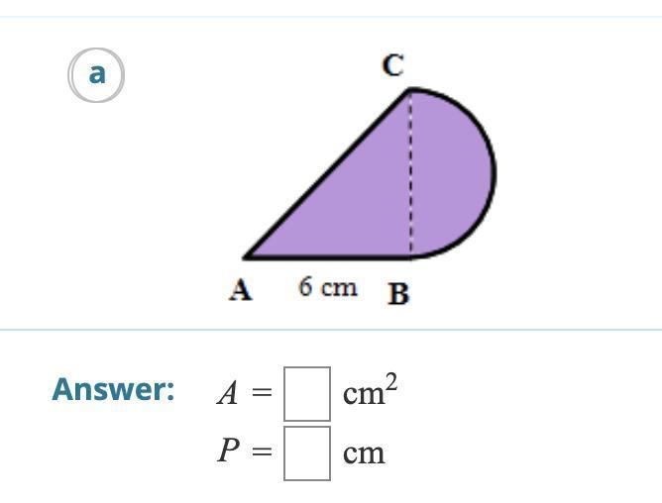
A semicircle is attached to one side of a triangle, often along its base.
$$A_{\text{total}}=A_{△}+A_{\text{semicircle}}$$
Since:
$$A_{△}=\frac{1}{2}bh$$
and:
$$A_{\text{semicircle}}=\frac{1}{2}πr^{2}$$
then:
$$\boxed{A=\frac{1}{2}bh+\frac{1}{2}πr^{2}}$$

2. Triangle + Circular Arc
# Source: AI Source: Provided by: [Data Path: Persons Table -> ID Column: 1, Name_En Column: Motasem Essam] -> From: [ChatGPT] on [7/25/2026]
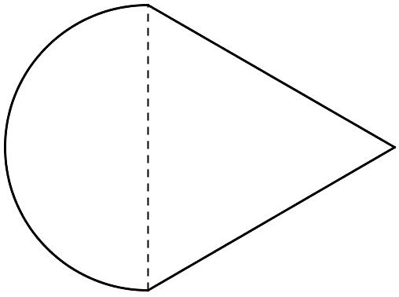

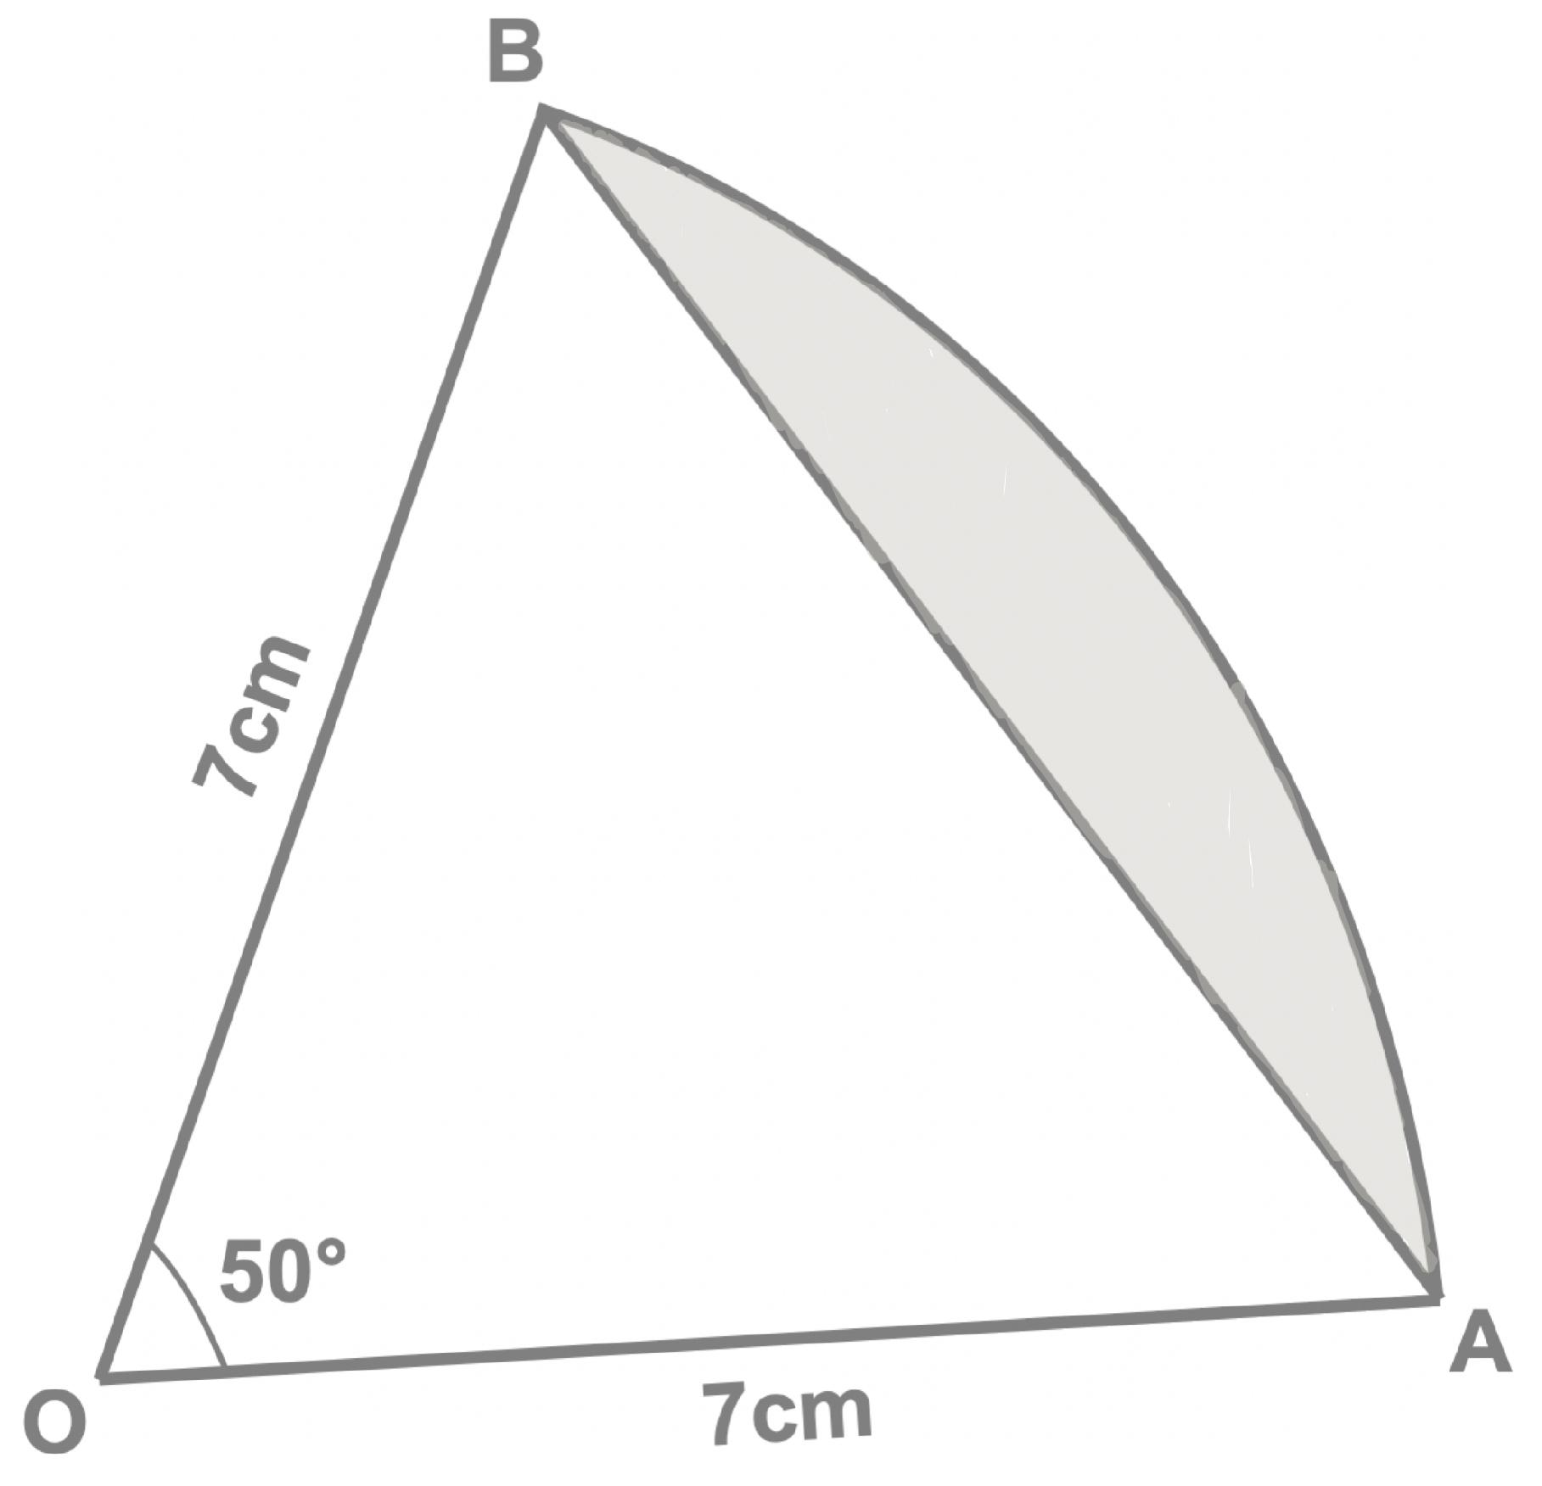

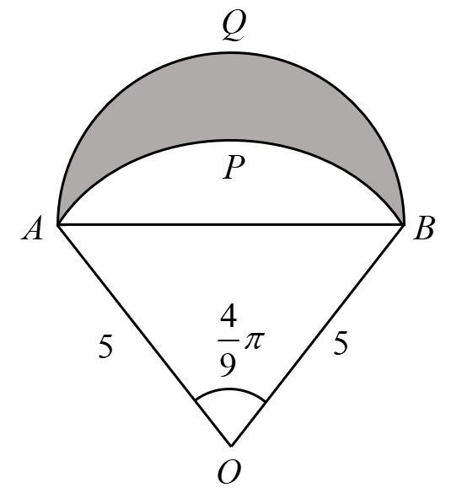
One side of the triangular region may be replaced or extended by a circular arc.
This produces a boundary containing both straight and curved sections.

3. Triangle + Quarter Circle
# Source: AI Source: Provided by: [Data Path: Persons Table -> ID Column: 1, Name_En Column: Motasem Essam] -> From: [ChatGPT] on [7/25/2026]
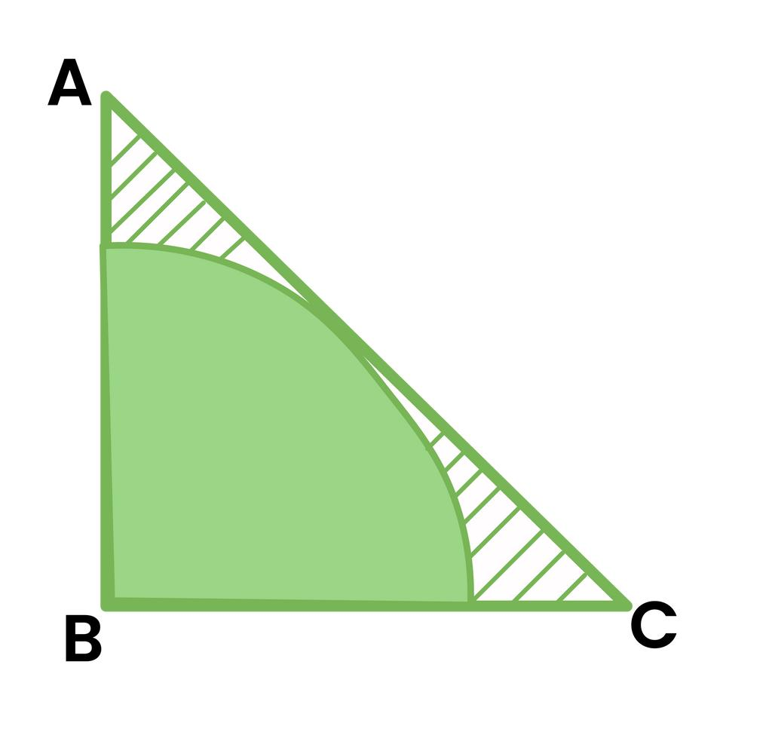
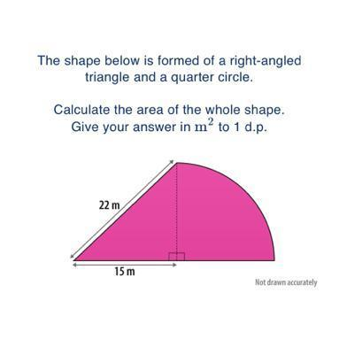
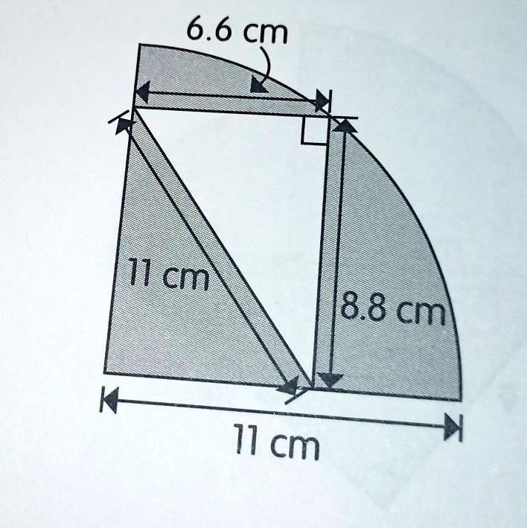
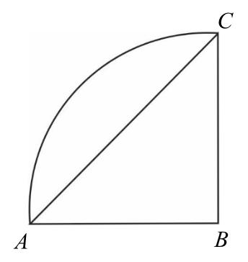
A quarter-circle component can be attached to a triangular region.
$$A_{\text{quarter circle}}=\frac{1}{4}πr^{2}$$

4. Triangle + Circular Segment
# Source: AI Source: Provided by: [Data Path: Persons Table -> ID Column: 1, Name_En Column: Motasem Essam] -> From: [ChatGPT] on [7/25/2026]
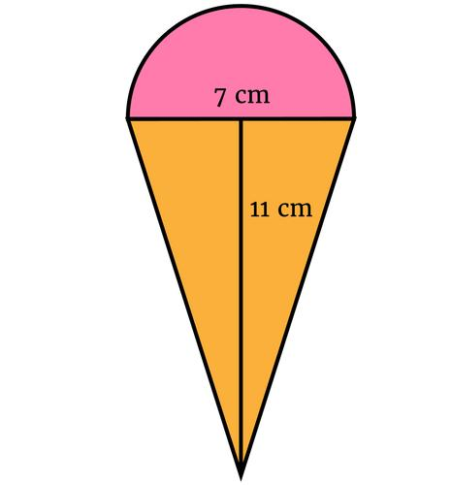
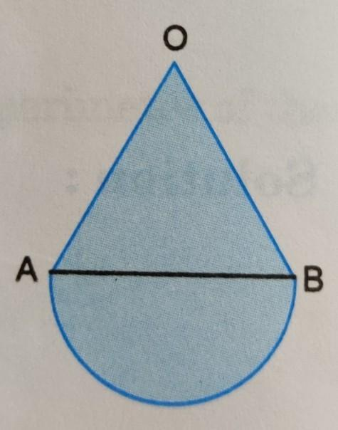


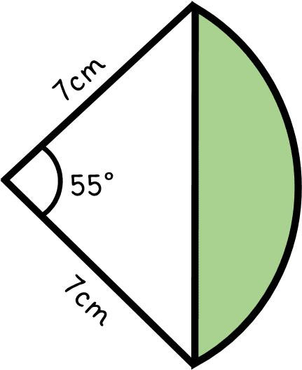
A circular segment can be combined with a triangle to produce an irregular composite boundary.

5. Triangle with Circular Cutout
# Source: AI Source: Provided by: [Data Path: Persons Table -> ID Column: 1, Name_En Column: Motasem Essam] -> From: [ChatGPT] on [7/25/2026]
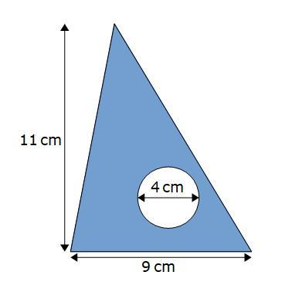
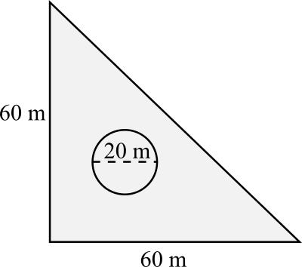
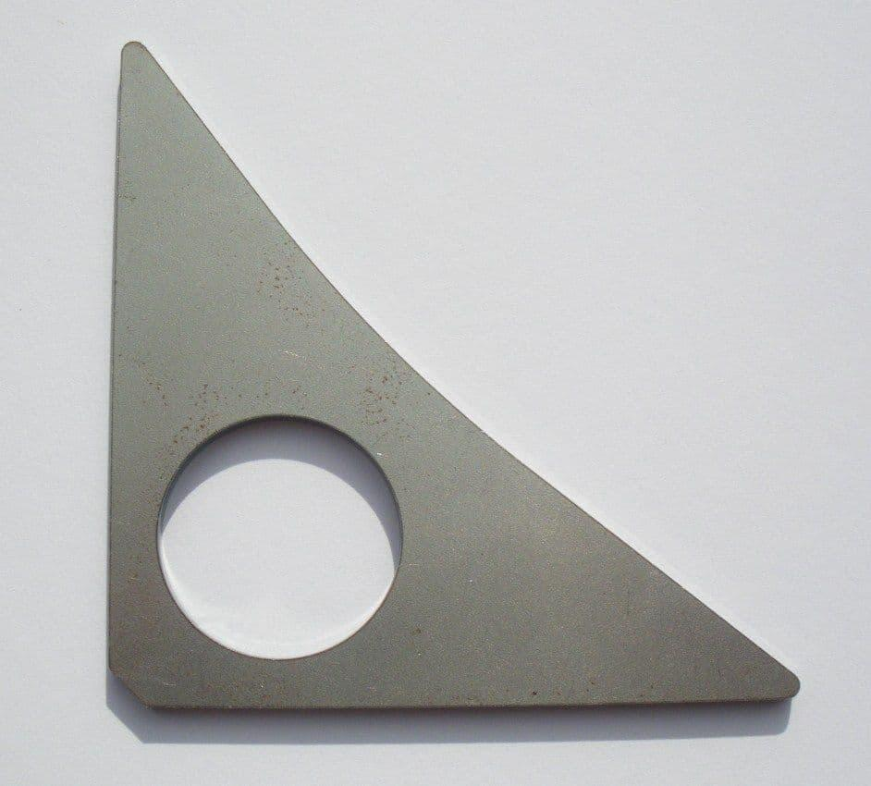
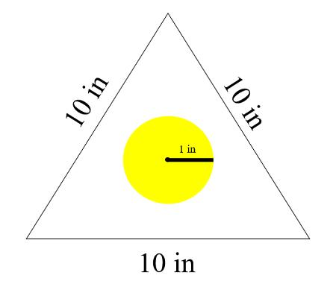
A circular region can be removed from a triangular region.
$$\boxed{A_{\text{remaining}}=A_{△}-A_{\text{circle}}}$$

6. Triangle with Multiple Circular Elements
# Source: AI Source: Provided by: [Data Path: Persons Table -> ID Column: 1, Name_En Column: Motasem Essam] -> From: [ChatGPT] on [7/25/2026]
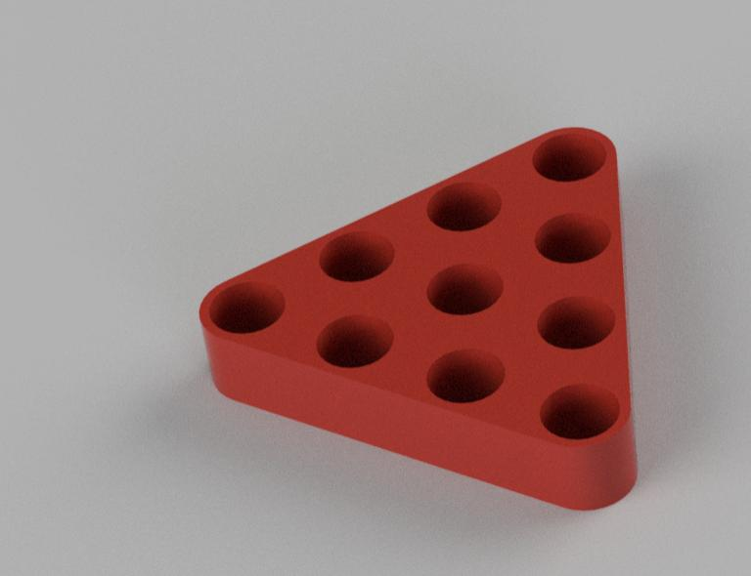
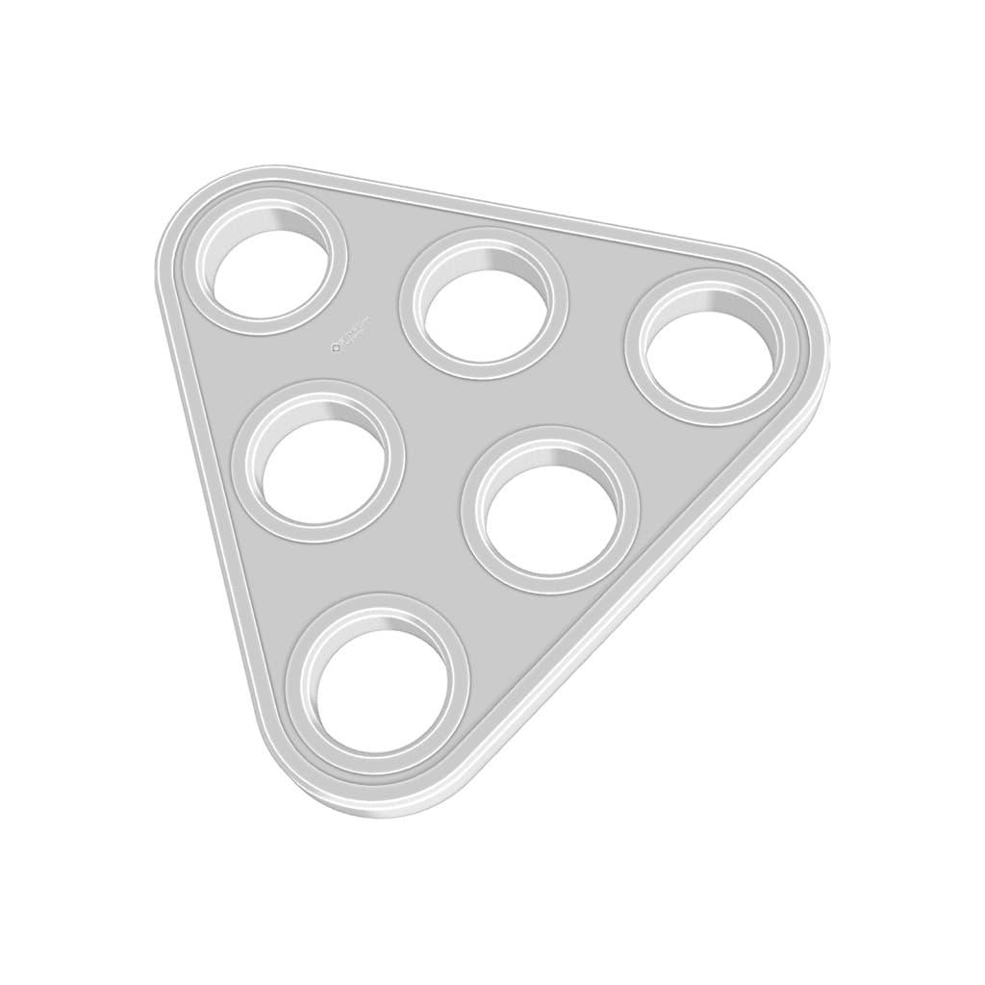
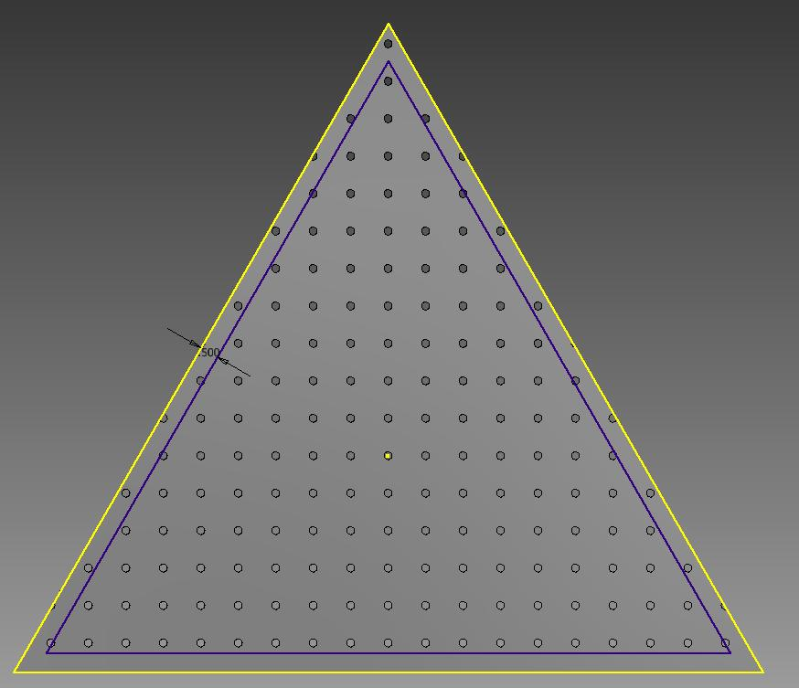
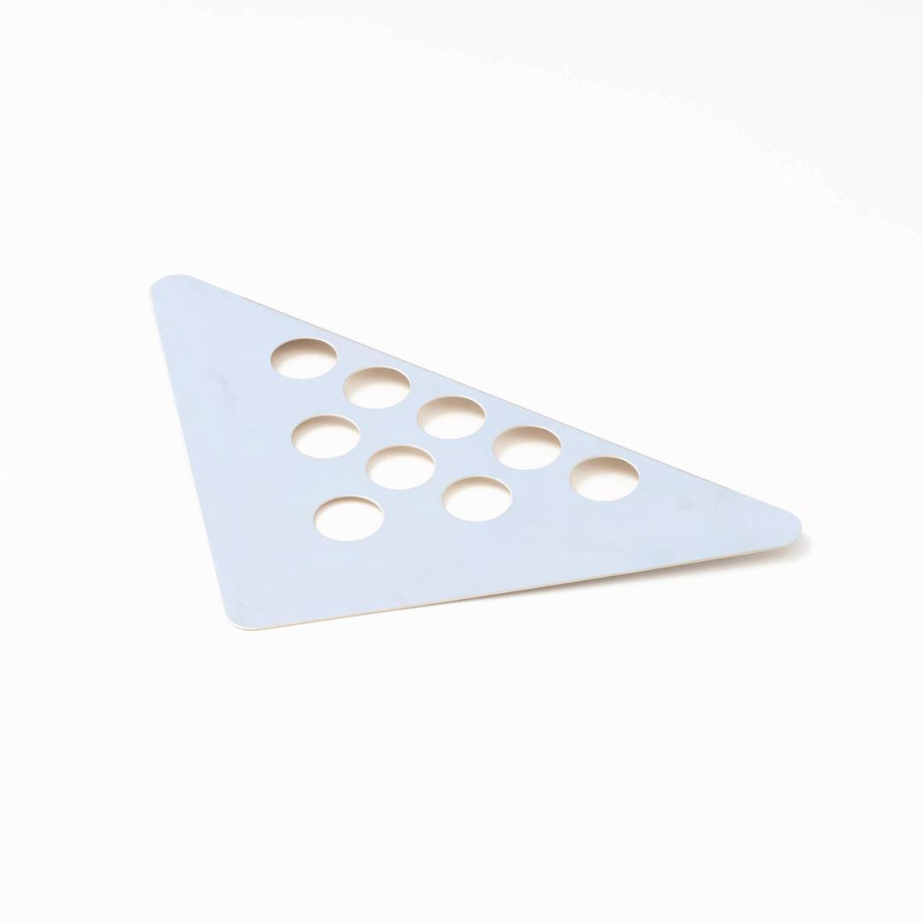
A triangular shape can contain several circular holes or circular features.
[
$$A_{\text{remaining}}=A_{△}-\sum{A_{\text{circles}}}$$]

Boundary Classification
# Source: AI Source: Provided by: [Data Path: Persons Table -> ID Column: 1, Name_En Column: Motasem Essam] -> From: [ChatGPT] on [7/25/2026]
A Triangle–Circular Mixed Shape contains:
[
$$\boxed{\text{Mixed Boundary}=\text{Straight Triangle Sides}+\text{Circular Arcs}}$$]
The three straight sides originate from the triangular component, while the curved portions originate from the circular component.

Area
# Source: AI Source: Provided by: [Data Path: Persons Table -> ID Column: 1, Name_En Column: Motasem Essam] -> From: [ChatGPT] on [7/25/2026]
The area is usually calculated by decomposition.
For example, for a triangle plus a semicircle:
$$\boxed{A=\frac{1}{2}bh+\frac{1}{2}πr^{2}}$$
For a triangle with a circular cutout:
$$\boxed{A=\frac{1}{2}bh-πr^{2}}$$
The exact formula depends on the configuration of the components.

Perimeter
# Source: AI Source: Provided by: [Data Path: Persons Table -> ID Column: 1, Name_En Column: Motasem Essam] -> From: [ChatGPT] on [7/25/2026]
The perimeter combines:
- Straight triangular sides.
- Circular arc lengths.
For a semicircular arc:
$$L_{\text{arc}}=πr$$
Therefore:
$$\boxed{P=\sum{L_{\text{triangle sides}}}+\sum{L_{\text{circular arcs}}}}$$
For a full circle:
$$C=2πr$$

Triangle–Circular vs. Rectangle–Circular Mixed Shapes
# Source: AI Source: Provided by: [Data Path: Persons Table -> ID Column: 1, Name_En Column: Motasem Essam] -> From: [ChatGPT] on [7/25/2026]
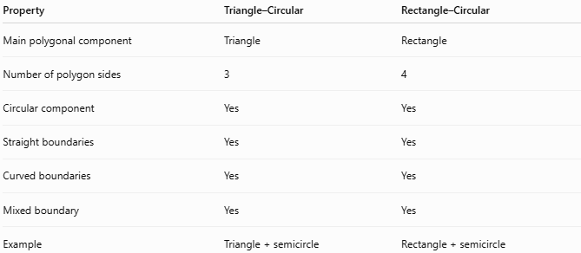
Property | Triangle–Circular | Rectangle–Circular
Main polygonal component | Triangle | Rectangle
Number of polygon sides | 3 | 4
Circular component | Yes | Yes
Straight boundaries | Yes | Yes
Curved boundaries | Yes | Yes
Mixed boundary | Yes | Yes
Example | Triangle + semicircle | Rectangle + semicircle
Both belong to the broader category:
$$\boxed{\text{Polygon–Circular Mixed Shapes}}$$
because both triangles and rectangles are polygons.

Key Points
# Source: AI Source: Provided by: [Data Path: Persons Table -> ID Column: 1, Name_En Column: Motasem Essam] -> From: [ChatGPT] on [7/25/2026]
A Triangle–Circular Mixed Shape combines:
$$\boxed{\text{Triangular Elements}+\text{Circular Elements}}$$
It:
- Contains a triangular component.
- Contains one or more circular or arc components.
- Has both straight and curved boundaries.
- Has a mixed boundary.
- Is generally an irregular composite shape.
- Can be decomposed into triangles, circles, semicircles, quarter-circles, or circular segments.
- Can have circular cutouts or circular additions.

Conclusion
# Source: AI Source: Provided by: [Data Path: Persons Table -> ID Column: 1, Name_En Column: Motasem Essam] -> From: [ChatGPT] on [7/25/2026]
Triangle–Circular Mixed Shapes are irregular composite shapes that combine the straight-sided structure of a triangle with circular elements or circular arcs. Common examples include triangles with semicircular bases, triangles with circular arcs, triangular regions with circular cutouts, and triangular shapes containing multiple circular features. They are useful in composite-area geometry, engineering, architecture, CAD, product design, and real-world shape modeling.

